**Student Assessment Submission and Declaration**

When submitting evidence for assessment, each student must sign a declaration confirming that the work is their own.

|  |  |  |  |
| --- | --- | --- | --- |
| Student name: Shahed Montaser | | Assessor name: **Hala Majdalawi** | |
| Issue date (1St Submission):  **7/5/2023** | Submission date (1St Submission):  **17/5/2023** | | Submitted on:  **17/5/2023** |
| In case of resubmission | | | |
| Issue date (1St Submission):  **20/5/2023** | Submission date (1St Submission):  **23/5/2023** | | Submitted on: |
| Programme: **HND in Cloud Computing - Cloud Software Development** | | | |
|  | | | |
| Assignment number and title: **1 Nitrogen Gym Database System** | | | |

**Plagiarism**

Plagiarism is a particular form of cheating. Plagiarism must be avoided at all costs and students who break the rules, however innocently, may be penalised. It is your responsibility to ensure that you understand correct referencing practices. As a university level student, you are expected to use appropriate references throughout and keep carefully detailed notes of all your sources of materials for material you have used in your work, including any material downloaded from the Internet. Please consult the relevant unit lecturer or your course tutor if you need any further advice.

**Student Declaration**

|  |
| --- |
| **Student declaration**  I certify that the assignment submission is entirely my own work and I fully understand the consequences of plagiarism. I understand that making a false declaration is a form of malpractice.  Student signature: Date: |

**First:**

User Requirements:

-Users should be able to add and edit personal details to their profiles, including their name, email address, country, phone number, age, weight, and date of birth.

-During the registration process, members should be allowed to choose their membership type (monthly or yearly).

-Each member should receive a customized training schedule from the system based on their fitness objectives, taste, and health status.

-Members ought to be able to monitor their accomplishments, measurements, and weight as well as their overall development.

-Members should be able to plan and reserve lessons using the system according to their preferences and availability.

-Members should be given recommendations for classes that complement their exercise routines and fitness objectives.

-For a smooth member experience, the system should offer a user-friendly interface with simple navigation and intuitive design.

-Members should be able to choose their privacy settings and have safe access to their personal information.

**System Requirements:**

-To guarantee seamless operation and no downtime, the cloud-based database system has to be scalable and capable of managing heavy loads during periods of peak demand.

-To guarantee dependable data transfer and reduce downtime, the system should have strong network connectivity and a solid infrastructure.

-To safeguard member data, stop illegal access, and guarantee the privacy and confidentiality of sensitive information, a thorough security system should be put in place.

-Access to member profiles, equipment specifications, and class information should be quick and accurate thanks to the database system's excellent data storage and retrieval capabilities.

-In order to protect data integrity and enable speedy restoration in the event of any system failures or data loss occurrences, the system should include backup and disaster recovery procedures.

**Second**:

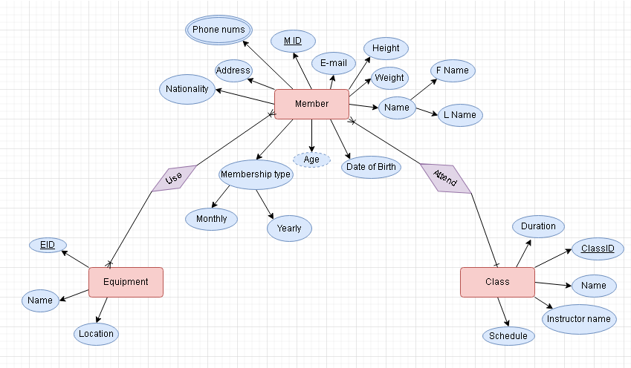

A logical database architecture that identifies the primary and foreign keys as well as the entities, their properties, and connections between tables:

Entities and Attributes:

1. Member

-ID (Primary Key)

-First Name

-Last Name

-Email Address

-Nationality

-Phone Numbers

-Age

-Weight

-Height

-Date of Birth

-Membership Type

2. Equipment

-ID (Primary Key)

-Name

-Location

3. Class

-ID (Primary Key)

-Name

-Instructor Name

-Duration

-Schedule

Member

|  |  |  |
| --- | --- | --- |
| Field name | Data Type | Constraints |
| M ID | Int | Primary key |
| F name | Varchar(50) | Not null |
| L name | Varchar(50) | Not null |
| Email | Varchar(100) | Not null |
| Address | Varchar(100) | Not null |
| Nationality | Varchar(50) | Default ( Jordanian) |
| Age | Int | Not null |
| Weight | Float | Not null |
| Height | Float | Not null |
| Date of Birth | DATE | Not null |
| Membership type | Varchar(50) | Not null |
| C ID | Int | Foreign key |

Equipment:

|  |  |  |
| --- | --- | --- |
| Field name | Data Type | Constraints |
| E ID | INT | PRIMARY KEY |
| Name | Varchar(50) | Not null |
| Location | Varchar(50) | Not null |

CLASS:

|  |  |  |
| --- | --- | --- |
| Field name | Data Type | Constraints |
| C ID | INT | PRIMARY KEY |
| Name | Varchar(50) | Not null |
| Instruction name | Varchar(50) | Not null |
| Duration | INT | Not null |
| Schedule | Varchar(50) | Not null |

Phone nums

|  |  |  |
| --- | --- | --- |
| Field name | Data Type | Constraints |
| Phone number | Varchar | Not null |
| MID | INT | Foreign key |

Mem-Equipment

|  |  |  |
| --- | --- | --- |
| Field name | Data Type | Constraints |
| MID | INT | Foreign key |
| EID | INT | Foreign key |

Relationships and Mapping:

*Member-Equipment (Many-to-Many)

MemberID (Foreign Key referencing Member)

EquipmentID (Foreign Key referencing Equipment)

*Class-Member (One-to-Many)

MemberID (Foreign Key referencing Member)

ClassID (Foreign Key referencing Class)

Database Schema:

Member

| ID (PK) | First Name | Last Name | Email | Address | Nationality | Phone Numbers | Age | Weight | Height | Date of Birth | Membership Type | C ID (FK) |

Phone nums

| Phone number| M ID (FK) |

Equipment

| ID (PK) | Name | Location |

Class

| ID (PK) | Name | Instructor Name | Duration | Schedule |

Mem&Eq

| E ID(FK) | M ID(FK) |

Member

|  |  |  |  |  |  |  |  |  |  |  |
| --- | --- | --- | --- | --- | --- | --- | --- | --- | --- | --- |
| M  ID | E_Mail | Address | Nationality | Phone num | D of B | Age | height | weight | Membership type | C ID |
|  |  |  |  |  |  |  |  |  |  |  |
|  |  |  |  |  |  |  |  |  |  |  |

Phone nums

|  |  |
| --- | --- |
| Phone number | M ID |
|  |  |

Equipment

|  |  |  |
| --- | --- | --- |
| E ID | Name | Location |
|  |  |  |

Class

|  |  |  |  |  |
| --- | --- | --- | --- | --- |
| C ID | Name | Instructor Name | Duration | Schedule |
|  |  |  |  |  |
|  |  |  |  |  |

Mem&Eq

|  |  |
| --- | --- |
| M ID | E ID |

There are a variety of cloud-based platforms, cloud hosting security, cloud hosting services, and cloud hosting vendors available for hosting the Nitrogen Cloud Database System. Here are some alternatives to think about:

*Platforms based in the cloud:

-Amazon Web Services (AWS): Through its platform known as Amazon Web Services, Amazon provides a wide range of cloud services, including databases, storage, and computing resources.

-Microsoft Azure: Through the Microsoft Azure platform, provides a full range of cloud services, including database solutions and hosting alternatives.

-Google Cloud Platform (GCP): Through the Google Cloud Platform, offers a reliable infrastructure for hosting databases and applications as well as a range of data management and analytics capabilities.

For the scenario, I chose AWS to deploy our database, because of the security, availability and

-Public Cloud: A cloud computing environment that is owned and managed by a different cloud service provider is referred to as public cloud. In a public cloud, the supplier offers numerous clients online access to resources such virtual computers, storage, and apps. Multiple users share the infrastructure and services, and the provider is in charge of administering and maintaining the cloud infrastructure. Amazon Web Services (AWS), Microsoft Azure, and Google Cloud Platform (GCP) are a few examples of public cloud service providers.

-Private Cloud: A cloud computing environment that is exclusive to one enterprise is known as a private cloud. It is often housed internally, in a data center run by the company or a different supplier, or both. In a private cloud, the infrastructure and services are not shared with other businesses, giving you more control, security, and customization choices. Companies that need to have total control over their data and resources, have unique security or compliance needs, or both frequently employ private clouds.

-Public and private cloud environments are combined to create a hybrid cloud. It enables businesses to combine the advantages of both kinds of clouds into one adaptable infrastructure. In a hybrid cloud environment, businesses can use the public cloud for some workloads while running others in the private cloud. Scalability, cost-effectiveness, and the flexibility to use outside resources while yet keeping control over sensitive data are benefits of this strategy. In order to provide seamless data transfer and workload management, hybrid cloud designs frequently incorporate secure connections between the public and private cloud components.

*Hosting in the cloud:

-Choose a database as a service (DBaaS) provider that offers managed database services, which will take care of the infrastructure, scalability, and maintenance of the database system.

-IaaS (Infrastructure as a Service): Pick an IaaS provider that enables you to set up and maintain your own cloud-based infrastructure to have greater control over the database environment.

-Platform as a Service (PaaS): Take into account a PaaS supplier who provides a whole platform for database administration, application development, and deployment.

Infrastructure as a service (IaaS) might be a good option in the described situation for developing a cloud-based database system for Nitrogen Gym. Consider IaaS for the following reasons:

- Scalability is a feature of IaaS that makes it simple to change the resources allotted to your database system in response to demand. IaaS can offer the ability to scale up or down the infrastructure to suit different workloads as Nitrogen Gym works with high load times and may face peak periods.

-IaaS suppliers generally provide a solid infrastructure with redundant systems and high availability. This makes it possible to keep the database system for the gym available and functional even when there are network or connectivity problems. It lessens the possibility of downtime and guarantees dependable access for workers, suppliers, and clients.

-Security: IaaS providers frequently employ cutting-edge security techniques to secure data and systems due to security and access issues in some less technologically sophisticated countries. Infrastructural management and security, including the use of firewalls, encryption, access restrictions, and data backups, are areas in which they are skilled. This might improve the Gym Database System's overall security, protecting member information and other sensitive data.

-Simple Updates and Maintenance: IaaS providers take care of all infrastructure-related duties, such as updates, patches, and maintenance. Since Nitrogen Gym acknowledged having problems with updates and network connectivity, this may be advantageous for them. By utilizing IaaS, the provider is given the responsibility for monitoring network and infrastructure changes, freeing the Nitrogen Gym team to concentrate on creating and improving the database system.

-Cost effectiveness: The pay-as-you-go IaaS approach lets you only pay for the resources you really utilize. As they can adjust resources in accordance with demand and prevent overprovisioning, Nitrogen Gym may find this to be financially advantageous. Additionally, they can reduce the need for physical infrastructure investment and upkeep, lowering initial expenditures and continuing operational costs.

-IaaS offers the ability to develop and adapt the database system in accordance with the needs of the gym specifically. It supports a number of database management systems and offers possibilities for interface with other services or apps, making it easier to create a system for recording your workouts and progress that is unique to you.

Additionally, a good choice for the Nitrogen Gym scenario is hybrid cloud. Here are some benefits of hybrid cloud technology:

-Data localization and compliance: In some circumstances, businesses may be required by regulatory or legal obligations to store certain data within a particular jurisdiction. By using a hybrid cloud strategy, Nitrogen Gym may maintain sensitive member data on a private cloud on their premises or meet data localization standards while using the public cloud for other non-sensitive data or less important operations.

-Enhanced Security: Nitrogen Gym highlighted worries about access issues and security issues in places with less sophisticated technology. They can store sensitive data, such as member personal information, on their private cloud using a hybrid cloud, which provides more protection and management. For other parts of their system, companies may take use of the sophisticated security safeguards put in place by respected public cloud providers.

-Resource Scalability: Nitrogen Gym is able to flexibly scale its resources in response to demand thanks to hybrid cloud. They may use the public cloud's scalability to manage higher workloads and guarantee excellent performance at busy times. As a result, they are able to avoid any performance problems or restrictions that would result from simply depending on their own cloud infrastructure.

-Redundancy and disaster recovery: The hybrid cloud enables the use of effective disaster recovery plans. In order to provide redundancy and lower the chance of data loss or system outages, Nitrogen Gym may replicate and backup their crucial data and applications across both private and public clouds. They can swiftly recover and restore services from the backup cloud environment in the case of an infrastructure breakdown or disaster.

-Cost Optimization: The hybrid cloud offers potential for cost optimization. For non-sensitive applications or short-term projects requiring a lot of CPU power, Nitrogen Gym can use the public cloud. As a result, they are able to pay just for the resources that are really used instead of having to make a large upfront infrastructure investment.

- Flexibility and Agility: The ability for Nitrogen Gym to select the best cloud environment for various system components makes hybrid clouds flexible and agile. While still keeping control over crucial data and systems within their private cloud, they may benefit from the scalability, simplicity of upgrades, and integration possibilities of the public cloud. With this flexibility, they can respond to shifting business requirements and benefit from the finest aspects of both cloud models.

*Cloud Hosting Providers:

-Amazon RDS: Amazon Relational Database Service (RDS) offers managed database hosting alternatives, including SQL Server, PostgreSQL, and popular database engines like MySQL.

-Microsoft Azure SQL Database: A fully managed database service that supports SQL Server and offers scalability, security, and high availability is made available by Microsoft Azure.

-Google Cloud SQL: A managed database service from Google Cloud Platform that supports PostgreSQL and MySQL and provides scalability, replication, and automatic backups.

Before choosing the best hosting choice, it's critical to weigh these possibilities according to aspects like cost, scalability, security, and the unique needs of the Nitrogen Cloud Database System.

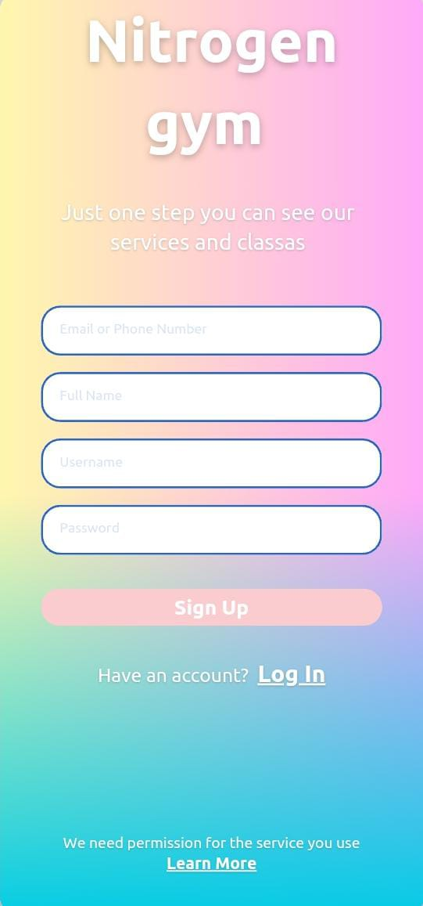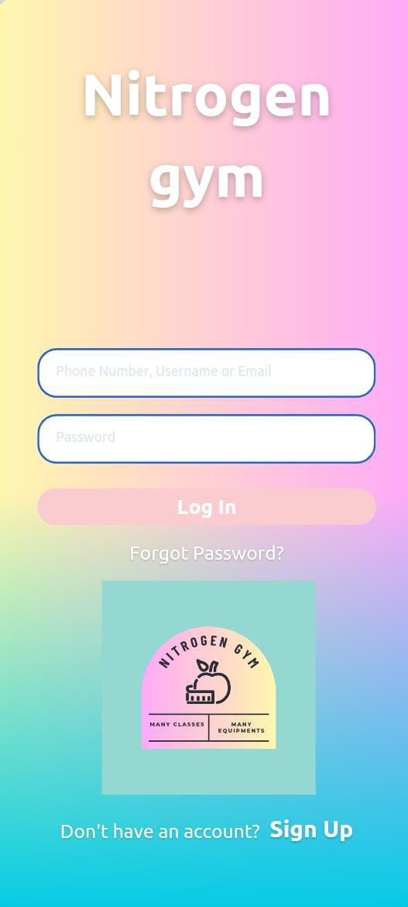

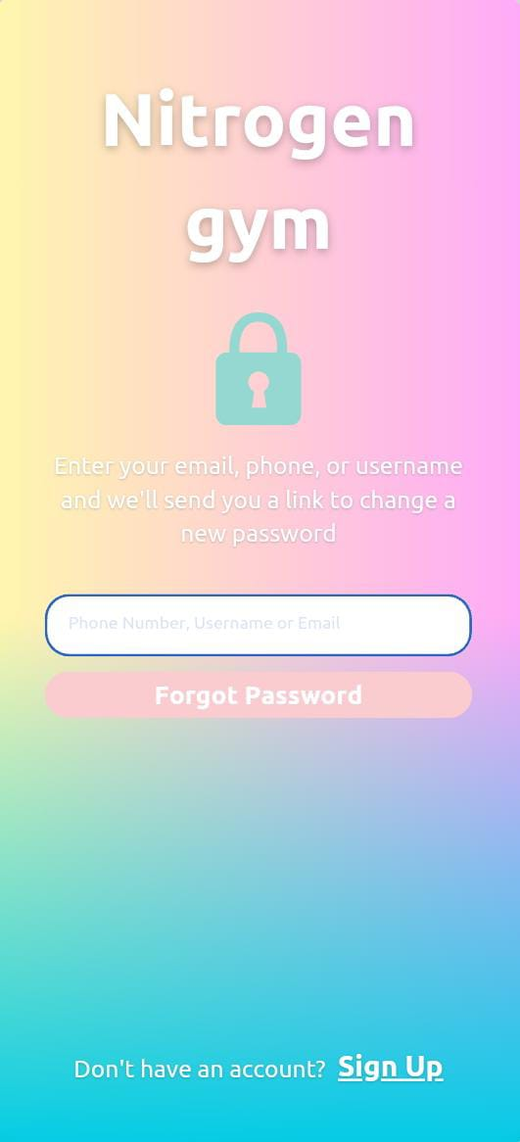

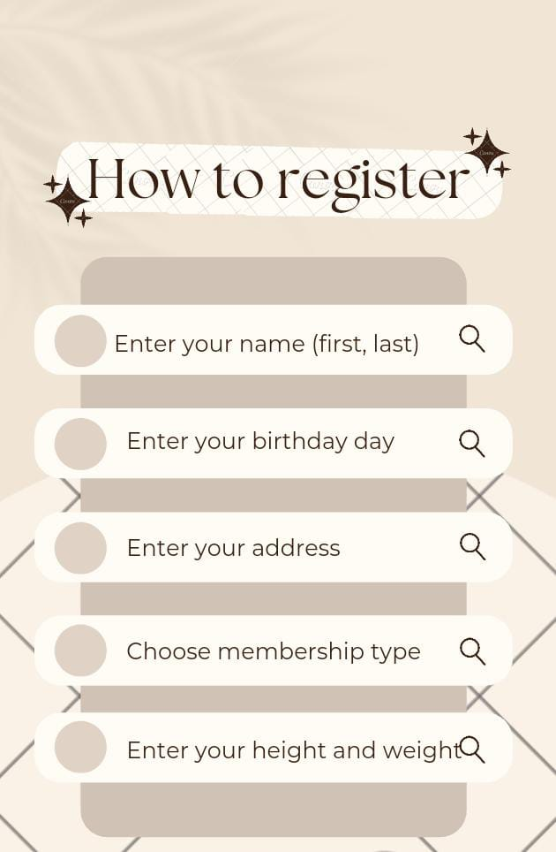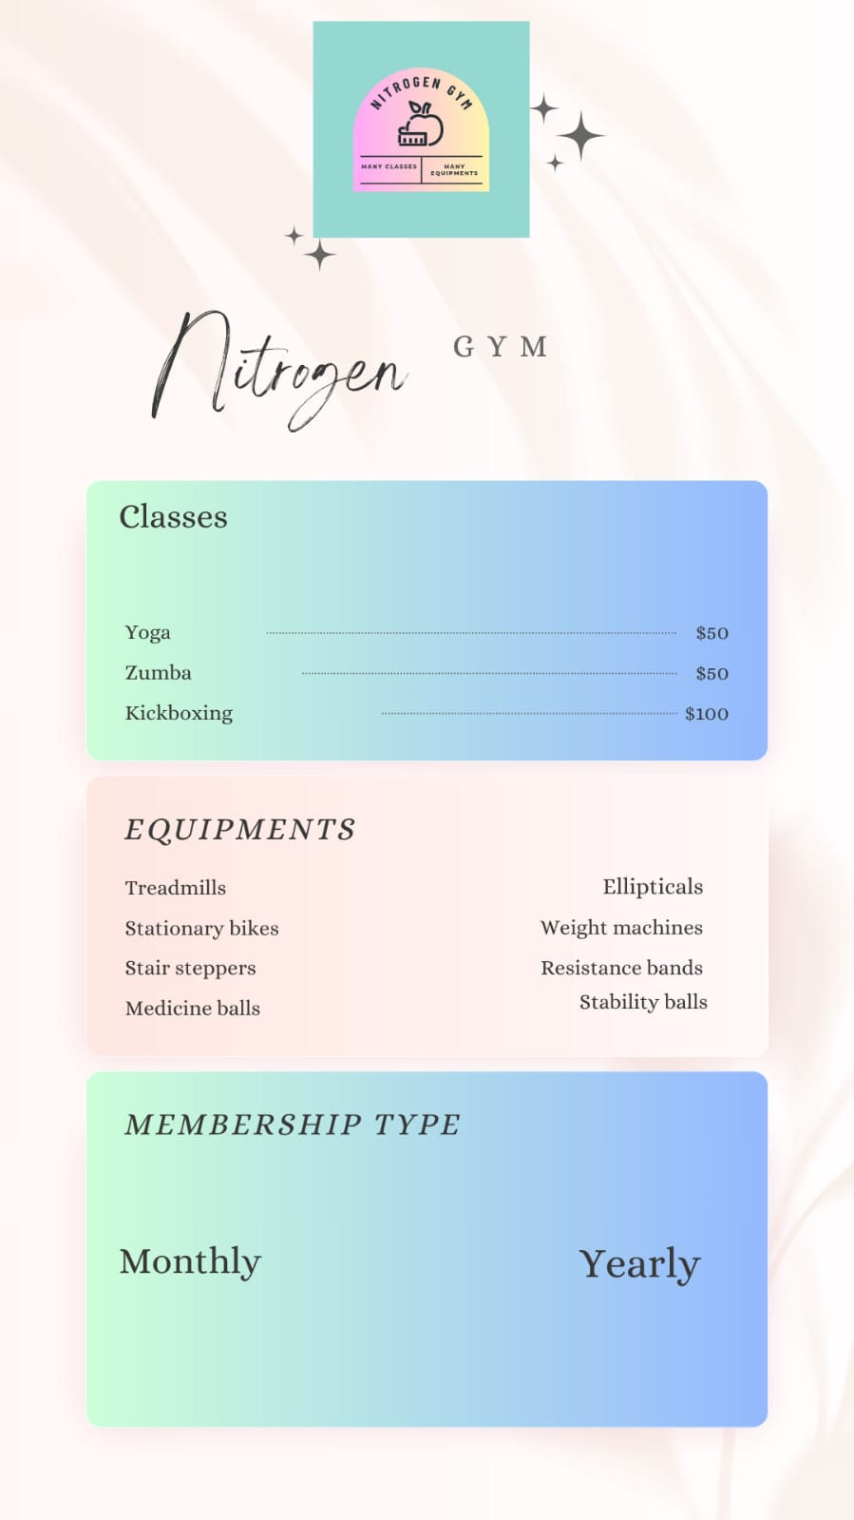



We must measure and take into account how effectively the design satisfies certain user and system criteria in order to assess the efficacy of the design on the selected cloud host technique. An assessment of the design elements is provided below:

-Diagram of entity relationships (ERD)

Evaluation of the ERD's representation of entities, their attributes, and interrelationships between tables.

Reflection: I made sure that the ERD accurately depicts all of the underlying entities (members, equipment, and classes) and their associated characteristics. Make that the connections between the tables are accurately depicted, such as those between MemberEquipment and MemberClass.

Efficiency: My ERD efficiently illustrates entity connections and database structure, allowing for better data administration and query operations.

- Schema for logical design:

Check the database's schema, paying particular attention to the fields, data types, constraints, primary keys, and foreign keys.

Consideration: I assessed how well the logical design diagram portrayed the tables, their attributes, and the relationships produced by the ERD. To ensure data integrity and preserve referential integrity, it was examined if primary keys and foreign keys were defined appropriately.

Efficiency: The logical design plan should give data storage, retrieval, and processing a strong basis, guaranteeing data correctness and consistency.

- Interface layout:

Measure: Assess the user interface, including the displays, forms, and user interactions.

In order to let members conveniently access personalized exercise programs, monitor their progress, and get suggestions for classes and equipment based on their fitness objectives, I evaluated if the interface design meets user criteria. Make sure the user interface is clear, simple to use, and responsive.

Effectiveness: The interface should be designed to improve the user experience, making it easy and entertaining to engage with the system while yet delivering the necessary functions.

- Chosen cloud host technique:

Measure the design's compatibility with the chosen cloud host strategy while taking into account variables like scalability, security, dependability, and cost.

Consideration: I assess if the design makes use of the cloud-based features offered by the selected host approach, such as managed database services, scalability choices, data encryption, and access restrictions. Examine if the design provides improvements in terms of updates, network connections, security, and accessibility and tackles the specific shortcomings of the current IT system.

Effectiveness: The design should explain how migrating to the cloud is applicable and advantageous, addressing the issues and enhancing the general effectiveness and efficiency of the Nitrogen Gym Database System.

You may analyze the success of the design in satisfying the defined user and system requirements and ascertain how well it fits with the selected cloud host technique by conducting a comprehensive review and reflection on these design components.